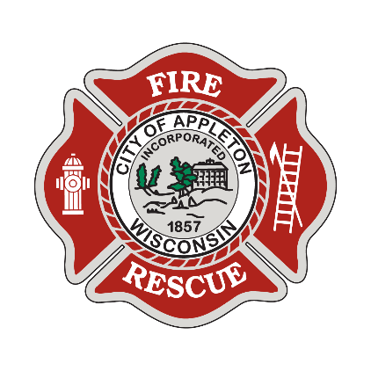


City of Appleton
Firefighter

At the City of Appleton, we welcome innovative individuals who love to lead and inspire others. Located in the heart of the Fox Cities, we are a steadfast employer committed to providing a flexible work environment and unique benefits. We encourage employees to come as they are and explore growth opportunities that will help them serve our community with impact.

Firefighters are responsible for performing fire operations and prevention duties. Work involves fire suppression, rescue, emergency medical services, extrication, inspection, public education, training, and engine company and/or ladder truck duties. Special operations include the Hazardous Materials Response Team, the Technical Rescue Team, Confined Space Rescue, Swift Water Rescue, Technical Rope Rescue and Trench Rescue. On average, the fire department responds to 7,000 calls annually. Firefighters may work individually or as a fire suppression team member and work under the regular supervision of a Fire Lieutenant, Captain, or Chief Officer.

Qualifications

Ready to Use Your Skills?

We are looking for someone who has a minimum of 60 credits of post-secondary education at an approved college, university, or technical school by the date of hire. EMT Basic and Firefighter I certifications are required. Candidates must be licensed, or have the ability to be licensed, as a Paramedic in the State of Wisconsin by the end of probation.

Salary
The starting annual salary for Firefighter/EMT is $72,427.47 plus an excellent fringe benefit package including: paid time off; health, dental and vision insurance; life insurance; short-/long-term disability insurance; accident insurance; health and wellness programs; post-employment health plan; deferred compensation; and Wisconsin Retirement System (WRS). We are proud to say the WRS is among the best funded and best managed public pension systems in the country!

Apply Now!
If you are interested in applying for this position, please complete an on-line application at appletonwi.gov/careers by Sunday, November 8, 2026. Resumes without an application will not be considered. Additional information on the position and department can be found in this brochure.

City of Appleton Human Resources
100 N. Appleton Street, 6th floor
Appleton, WI 54911
Phone: (920) 832-6458
Email: humanresources@appletonwi.gov
Equal Opportunity Employer

